Final Report

Mark Santiago
Rutgers University
04:189:220:91: Data In Context
Professor Jonathan Bullinger
December 10, 2025

Our group was tasked to evaluate the performance of image-based algorithms, more specifically, on facial recognition. For this project, Google Vision API was used for facial detection and emotion recognition. We then split up and compiled a dataset of 90 artificially generated images. This dataset was audited manually to determine demographic data like age, gender, and ethnicity since Google Vision does not return demographic labels. With this dataset, Google Vision API returned almost consistently accurate results in regards to features such as emotions, facial landmarks, and head angle.
When selecting Google Vision API, it is important that it is clarified what it is and what it is not capable of doing. According to documentation provided by Google, Google Vision API is capable of facial detection, emotion recognition, and detection of occlusions. Google Vision API is able to perform facial detection, determining if a face is in an image or not, by detecting facial landmarks like eyes, nose, and mouth, complemented by detecting bounding boxes. Another feature that Google Vision can detect is the facial positioning properties within an image. Google Vision can detect roll angle, tilt angle, and pan angle. Furthermore, using these detections, it can detect emotions like joy, sorrow, and anger. When detecting these emotions, it will return metrics for each emotion, respectively, returning unknown, very_unlikely, unlikely, possible, likely, and very_likely. Finally, the service also has detection of occlusions such as headwear, blurred faces, etc., although not used within our dataset. On the other hand, Google Vision API does not detect demographics. This includes age, gender, and race. Additionally, it does not provide identity detection. This leaves demographic analysis to auditors, which may add its own limitations.
When manually auditing demographic data, we had to make sure we made it as reliable and unbiased as possible. Because this data was manually audited, when filtering for images on websites that generated people, we strictly based our demographic on the filters provided on those websites, even if we doubted them. These races included Asian, Black, Latino, and White. Furthermore, we also had to manually identify gender categories between male and female, and age categories– child, teen, young adult, adult, and elderly. We tried to make as many intersectional combinations as possible when generating images to make the data the most diverse we can. As stated earlier, Google Vision API is reliable and valid according to the documentation given to us; it does not detect people; rather, the features of these people. This led to a group ranking for the quality of results. The quality of results was determined based on the algorithm's ability to successfully determine emotion, bounding box, and facial orientation. Once this data was collected, we determined that emotion had the highest weight and was generally what made the quality of results high or low. Across all boards, Google Vision API had consistent results, not favoring one demographic above another. This means that the average highest results and the average lowest results never truly favored one specific group. This relates to the concept of algorithmic fairness, which is the idea of equal error rates between all groups.
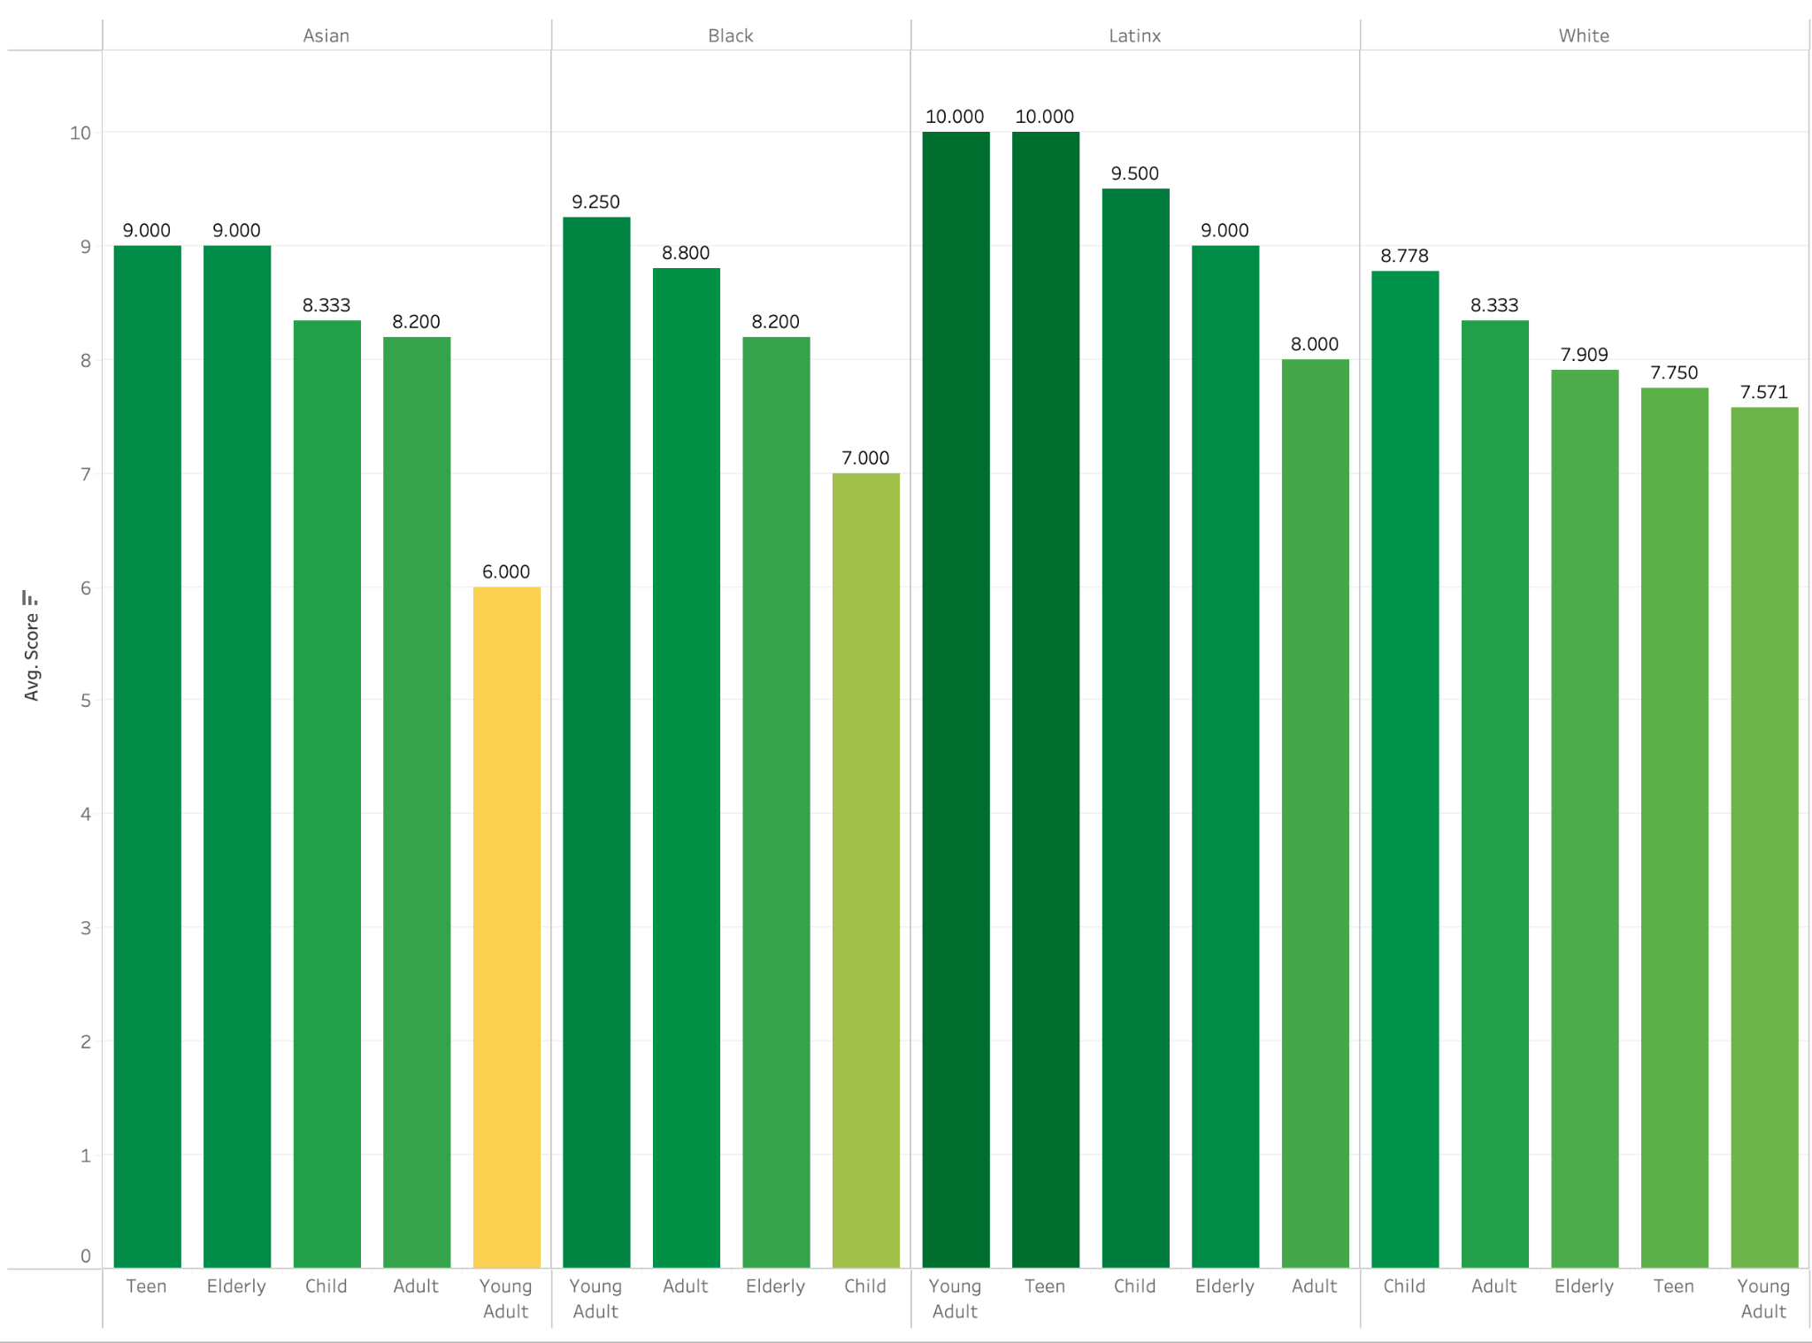
In this visualization, a histogram is used to show the distribution of average scores between ethnicities and age. This visualization gives us insights as it shows which demographics, age, and gender were the most accurate, and which demographics were the least accurate. As a reminder, this visualization does not determine the highest scores in terms of demographics, but whether or not the algorithmic model can determine emotion and head position accurately.
For the most part, Google uses ethical AI governance, with its documentation. Google does a good job addressing transparency and providing data like confidence intervals so people understand where and how the predictions are made. However, some recommendations that would address fairness would include initiatives to improve model performance. One way that this could be done is to retrain on more balanced and intersectional datasets. Additionally, more continuous third-party audits could be used for lower-confidence predictions. Building on this, Google could also strengthen its user-facing explanations by offering clearer descriptions of model limitations and potential sources of bias so that individuals can make more informed decisions when interpreting results. It may also be beneficial for Google to implement regular bias stress-testing across diverse demographic scenarios to identify potential blind spots before deployment. Combined, these steps would not only enhance public trust but also ensure that the system remains accountable and aligned with evolving ethical expectations.
Because most of this data was manually audited, many issues and limitations arose. For example, since there are only 90 pieces of data, a relatively small sample size, it is not normalized and cannot be fairly used. Another limitation our group faced was the labeling of demographics. Because we wanted to be as objective as possible, we used the labels based on the websites we used, even if we doubted whether they were truly accurate. Furthermore, another limitation that was an oversight on our part is the lack of emotions on one of the websites we used. One website only allowed for neutral and happy emotions, so we group members tasked with using that website, may have overinflated the statistics for those emotions. Another potential limitation can be coding. Coding to use the API may have been an error; this could have been due to time constraints or not getting a deeper understanding of the API’s capabilities when reading the documentation. All-in-all, these findings cannot be generalized globally due to these limitations, as validity threats and sampling bias may occur.
Google Vision API has served as a useful tool to analyze data such as emotion recognition, facial landmark recognition, and facial position during our study. Using a dataset of 90 artificially generated humans, Google Vision API was used to determine these factors and given an accuracy score by human auditors. Using Google Vision’s API facial recognition feature did not have any inherent biases across the board; rather, it was the human auditors who did. This could be attributed to our workflow, strictly using labels already given to us, despite our accuracy. On the other hand, Google Vision overall showed good performance; however, we do believe that there should be an emphasis on intersectionality, not just for Google Vision, but for all algorithms, as many people have many unique identities; single-axis labelling may oversimplify the data, which are real people.

